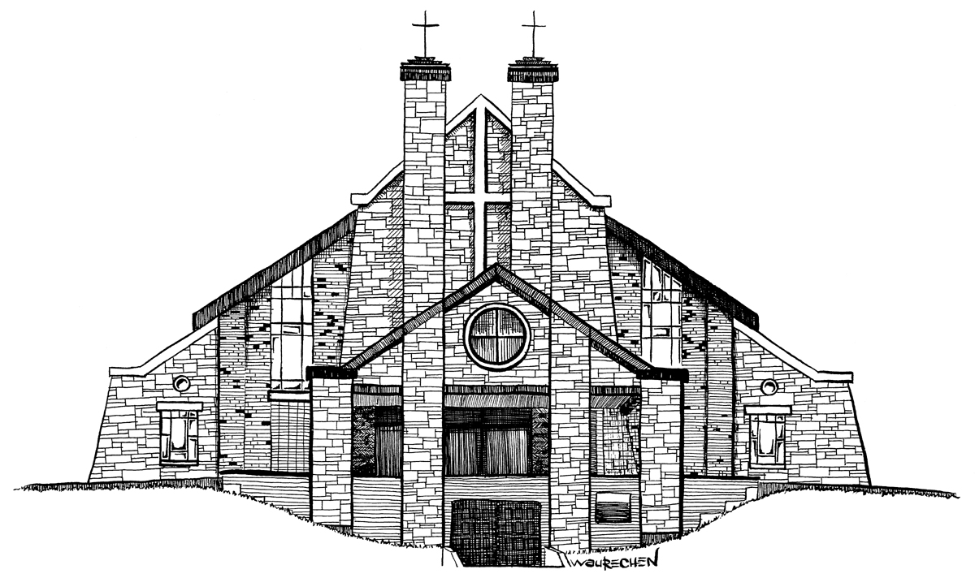
Our Lady of Lourdes Parish
Annual Report
2024
173 Lourdes Street
Waterloo, Ontario
N2L 1N5

Message from Our Pastor

Dear Parishioners:

As I come to the end of my first year at Our Lady of Lourdes Parish, I would first like to thank everyone for your warm welcome and acts of kindness to me over the past year, making this transition easier. We also welcome Deacon T.J. to our parish and look forward to his parish ministry.

This month the church also celebrated the election of Pope Leo XIV. At his first Regina Caeli address on Good Shepherd Sunday, echoing the words of Pope John Paul II, he said, “To young people I say: Do not be afraid! Accept the invitation of the Church and Christ the Lord!”

It is a message for all of us and as a parish we are called to be missionaries to proclaim the Word with courage and be a visible sign of the Church in our community. The very life and mission of the church is founded in the parish community where the People of God gather and care for one another. Our Lady of Lourdes stands as a beautiful church as a testimony to the faith of her people, and the building and property have all been well maintained over the years.

The only significant source of income for the parish is the Sunday Collection, so thank you to everyone who supports the parish in this way. We are all aware of rising costs today, so it is important that we support the parish financially according to our own means in making a sacrificial offering.

We also support and fulfill our mission as a parish by volunteering our time and sharing our skills and talents. This year I am particularly thankful to the people who formed teams and developed a program to prepare children for the Sacraments of First Eucharist and Confirmation. The operating of a parish, and what we can and cannot do, largely depends on the number of people to help out, so please consider volunteering your time and offering initiatives to the parish.

The following is the Finance Report of the parish for the year 2024. The report was prepared by the parish Financial Committee for whom we are grateful for their service and dedication to help direct and manage the finances of the parish.

As the report indicates, the bottom line is that the parish continues to operate in a deficit and the goal is to get our weekly collections to match our minimum targeted goal of $6500 a week.
And, your help to reach this goal would be appreciated.

As the school year winds down and holidays begin, may you all have a relaxing and enjoyable summer, and may Our Blessed Mother continue to keep us and our loved ones in her care and guide our parish.

Fr. Steve Murrin
Pastor

Spiritual Report
Registered families in the parish 1,585
Baptisms 32
Confirmations 41
First Communions 57
Marriages 6
Funerals 15
Enrollment at Our Lady of Lourdes School 371
Enrollment at Holy Rosary School 546
Students enrolled in the Catechetical Correspondence Course 1

Parish Ministries and Organizations

Ministers of the Word Finance Council
Extraordinary Ministers of Holy Communion Property & Maintenance Committee
Altar Servers Volunteer Screening Committee
Ministers of Hospitality (Ushers) St. Vincent de Paul Society
Music Ministry - choirs, musicians OLOL Café
Liturgy of the Word Program Funeral Reception Volunteers
Divine Mercy Chaplet Group Coffee Weekend Volunteers
Seniors’ Social Group Prayer Shawl Ministry
Collection Counters Living Rosary
Parish Social Committee Small Faith Group
Living Rosary

Message from the Parish Finance Council
Dear Parishioners,

In accordance with Diocesan guidelines, the Finance Council provides financial accountability and governance, and this report offers a comprehensive overview of the parish's 2024 income and expenditures.

The Finance Council includes Father Steve and three (3) lay volunteers who meet at various times throughout the year to review and approve financial statements, significant expenditures and other transactions that may impact the financial state of the parish.

2024 Financial Highlights were:
- Donations and Receipts received by the Parish were $522,697.89.
- Total Expenditures were $558,523.92, which included significant improvements to the church as detailed on page 6 in the Message from the Property & Maintenance Committee.
- A Deficit of ($35,826.03).
- Average weekly attendance increased almost 3% compared to 2023.
- The weekly collections average of $6,394, including pre-authorized payments, were less than in 2023.
- The Parish used $10,000 from the funds on deposit at the Chancery (which was mostly offset by the interest earned) to offset some of the expenses in 2024.

The 2025 weekly donations target was set at $6,500, in line with current values of an average of $6,394 per week in 2024. The Finance Council has also prepared an operating budget and will monitor the results at our regular meetings. We do not anticipate major extraordinary expenses in 2025.

We sincerely thank you, the parishioners, for your continued financial support of your parish community. In line with our current deficits for the past two (2) years, we ask you to review your donations and adjust them if you can.
The monthly debit plan has been very helpful in smoothing out our parish donations. If you wish to use the pre-authorized payment plan, please contact the office to set it up.
If you have any questions regarding the financial report, please contact the office or a member of the Finance Council.
May God’s Blessing be with all of you.
Sincerely,
Parish Finance Council

Fr. Steve Murrin, Pastor 519-886-0342
Danny McKinnon 226 791-7151
Alun Masterton 519-576-1082
Karin Voisin 226-749-3602
Our Lady of Lourdes Church
Statement of Donations, Receipts and Expenditures Year ended December 31, 2024

Our Lady of Lourdes Church
Balance Sheet with Previous Year Comparison as of December 31, 2024
2024 Monthly Contributions
 | Jan. | Feb. | March | April | May | June | July | August | Sept. | Oct. | Nov. | Dec. | Total
Envelopes  & Loose &  e- transfer | 11,532 | 13,869 | 16,665 | 17,075 | 17,083 | 12,003 | 13,564 | 10,215 | 22,082 | 11,991 | 11,843 | 29,138 | 187,060
Preauthorized Giving | 12,270 | 11,995 | 12,195 | 12,110 | 12,140 | 12,140 | 12,604 | 11,825 | 12,100 | 12,150 | 11,773 | 12,150 | 145,452
Total | 23,802 | 25,864 | 28,860 | 29,185 | 29,223 | 24,143 | 25,604 | 22,040 | 34,182 | 24,141 | 23,616 | 41,288 | 332,512
Average Weekly Attendance by Mass Time for 2024
(not including Easter and Christmas)
 | Jan | Feb | Mar | Apr | May | Jun | Jul | Aug | Sep | Oct | Nov | Dec
7:00 p.m. | 77 | 102 | 113 | 90 | 96 | 85 | 92 | 86 | 91 | 80 | 89 | 84
9:00 a.m. | 161 | 202 | 191 | 133 | 193 | 184 | 179 | 162 | 165 | 163 | 184 | 187
11:00 a.m. | 141 | 171 | 202 | 164 | 172 | 161 | 156 | 142 | 161 | 174 | 189 | 171
Total | 379 | 475 | 506 | 387 | 461 | 430 | 427 | 390 | 417 | 417 | 462 | 442
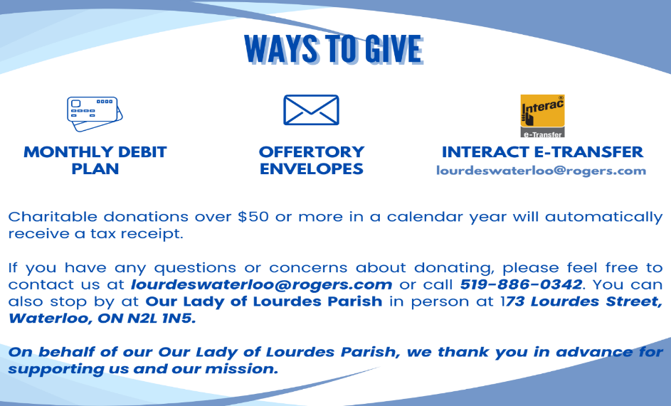

Message from the Property & Maintenance Committee
The Property and Maintenance Committee met several times to review and plan ongoing projects.

In addition to the regular maintenance and upkeep of the church, the following summarizes the major expenditures:
Completed projects for 2024 included-
- Replacement of the Sound System Amplifiers to improve the sound quality
- Completion of the installation of the high-efficiency replacement boiler balance of payment was made in 2024
- Added electrical outlets and new ventilation in the Parish hall kitchen plus an Electrical Panel upgrade
- Renovate the Music Room / Children’s Room into the Activity Room to better serve the needs of the Parish
- The Rectory Kitchen Appliances were replaced and the Yard was cleaned up and sodded
Planned projects for 2025 include-
- Major repairs to the Retaining Walls along the Driveway
- Install Commercial Dehumidifier for the Hall
Report for the Year Ended December 31, 2024
 | Regular Maintenance
 | Groundskeeping/snow blowing | $43,518.75
 | Custodial | 21,348.96
 | Electrical, Plumbing, Heating / Cooling System Repairs | 13,531.91
 | Inspection fees & Maintenance of Elevator & Alarms | 2,019.90
 | Rectory Kitchen Appliances & Electrical | 7,253.27
 | Administration Offices and Rectory General Maintenance | 14,848.88
 | Other Church Repairs and Maintenance | 18,955.83 | $121,477.50
 | Extraordinary Items
 | Replace Furnace & AC in Administration Offices | $9,397.90
 | Replace Chairs in the Hall | 2,095.00
 | Replace Amps for Church Sound System | 4,859.50
 | Completion of Boiler Replacement | 36,917.48
 | Activity Room Renovation in the Hall | 36,274.23
 | 65" TV for Activity Room | 1,224.98
 | Electrical Upgrade to Hall | 10,787.76 | $101,556.85
 | Total Maintenance and Extraordinary Expenses |  | $223,034.35

Note re Contractors- Our Lady of Lourdes uses contractors and volunteers rather than employees to do most of the regular maintenance work.

